MQTT Block Controller
Instructions

Description
The MQTT Block Controller is designed to provide everything required to operate one block, or what may be called a track circuit. Its small size makes it easier to hide under the track.
- DCC track power, 1A current limited, voltage regulated, and short circuit protected.
- Inductive occupancy detector, with adjustable sensitivity.
- Three 3.3v signal light outputs with built in resistors.
- One auxiliary 3.3v output.
- ESP8266-based Wemos D1 Mini providing WiFi connection to MQTT and JMRI.
- User-programmable addresses for inputs and outputs.
- Built in sensor de-bouncing provided in the Mini’s program.
- Connects to the base station DCC signals and 5V power with standard CAT5 cables.

Assembly

Surface Mount Parts
The surface mount parts need to be soldered onto the board before the through-hole parts since the top surface needs to be laid flat on the “cookie sheet”. My cookie sheet is a piece of 1/16” thick aluminum big enough to cover the hot plate, with a wooden handle attached. My hot plate is actually a heater section from a semiconductor wafer oven with a digital controller.
Set the hot plate to 250ºC. Having the hot plate too hot will cause some of the parts to dance around when the flux boils. Check the profile included with the solder paste for details.
The surface mount parts chosen for this project are large enough to allow for manual solder paste application and part placement, even if you’re not an expert. The only exception is the driver chip on the shield.
Apply solder paste to all the pads, then place each part, being careful to observe the polarity of the diodes and orientation of the L293DD.
Place the board(s) on the cookie sheet then place the cookie sheet on the hot plate. Watch the boards carefully so you can nudge parts back into place if they move. Carefully remove and let cool when everything flows nicely.
Table 1: Surface Mount Parts Needed
Qty | Part | Value | DigiKey # | Device
3 | C2,3,6 | .1uF | 399-C1206C104K5RAC7800CT-ND | C-USC1206
2 | C5,7 | .47uF | 399-8201-1-ND | C-USC1206
1 | D1 | S1BBTR | 1655-2315-1-ND | DIODE-DO-214AC
1 | D2 | 1N4148 | 1N4148WTPMSCT-ND | DIODE-SOD123
1 | IC1 | 7815DT | MC7815BDTRKGOSCT-ND | 7818DT
1 | IC2 | L293DD | 497-1390-5-ND | L293DD
1 | R1 | 2M trimmer | 3314G-205ECT-ND | R-TRIMM3314G
1 | R2 | 182K 1% | 311-182KFRCT-ND | R-US_M1206
3 | R3,4,5 | 1K | 311-1.0KERCT-ND | R-US_M1206
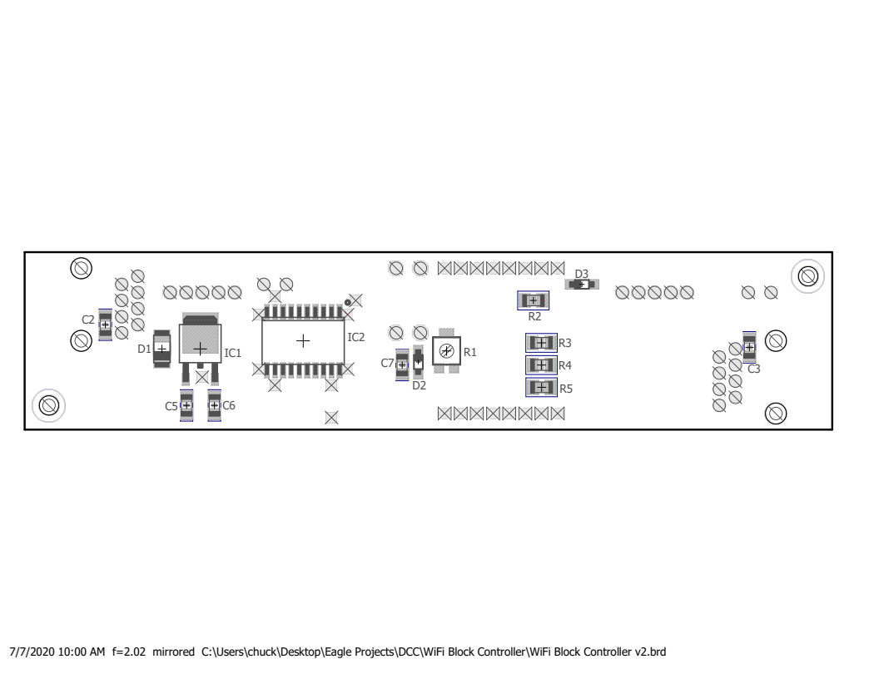Figure 1: Surface Mount Parts Placement
After the board(s) cool, use a magnifying glass to check for bridging between the pins of the driver chip and if any is found, remove it with solder wick or a fine point soldering iron. Also check for parts that may be missing solder.

Through-Hole Parts
Prepare the D1 Mini first. Hopefully you bought your minis with the headers included. Solder the male headers onto the D1 Mini, tacking only one pin at first to make sure the header is perpendicular to the board, then solder the rest of the pins.
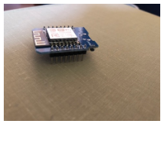Figure 2: Mini with male headers installed.
If this is a version 2 board, cut the trace going to between diode D2 and pin D0 as shown. This is corrected on version 3.
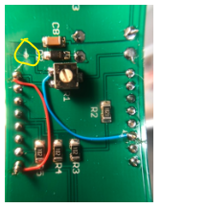Figure 3: Cut trace as shown.
To ensure good alignment of the short female headers on the circuit board, install them onto the pins of the Mini, then insert the headers and Mini into the top of the block controller board.

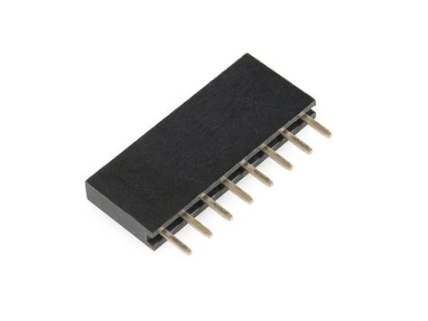Figure 4: Short female header.

If this is a version 2 board, don’t solder the pin labelled D1. It will need to a jumper wire added.
Solder the remaining pins of the headers.
If this is a version 2 board, connect a wire wrap wire (#30 solid) jumper from the junction of R1, D2, and C8 to Mini pin D1. Solder the pins where the jumpers attach.
Remove the Mini and install the remaining through-hole parts. Make sure to observe the polarity of C1 and C4.
Table 2: Through-Hole Parts Needed
Qty | Part | Value | DigiKey # | Device
2 | C1,4 | 100uF | 493-1107-ND | CPOL-USE3.5-8
2 | J1,2 | 5555164-1 | A31442-ND | 520426-4
2 | TS1,2 | 5 pos term block | A98336-ND | TERMBLK05
2 | P1,2 S1,2 | 35T0231-00P | 240-2584-ND | See Instructions
1 | U$1 | WEMOS-D1-MINI | na | See Instructions
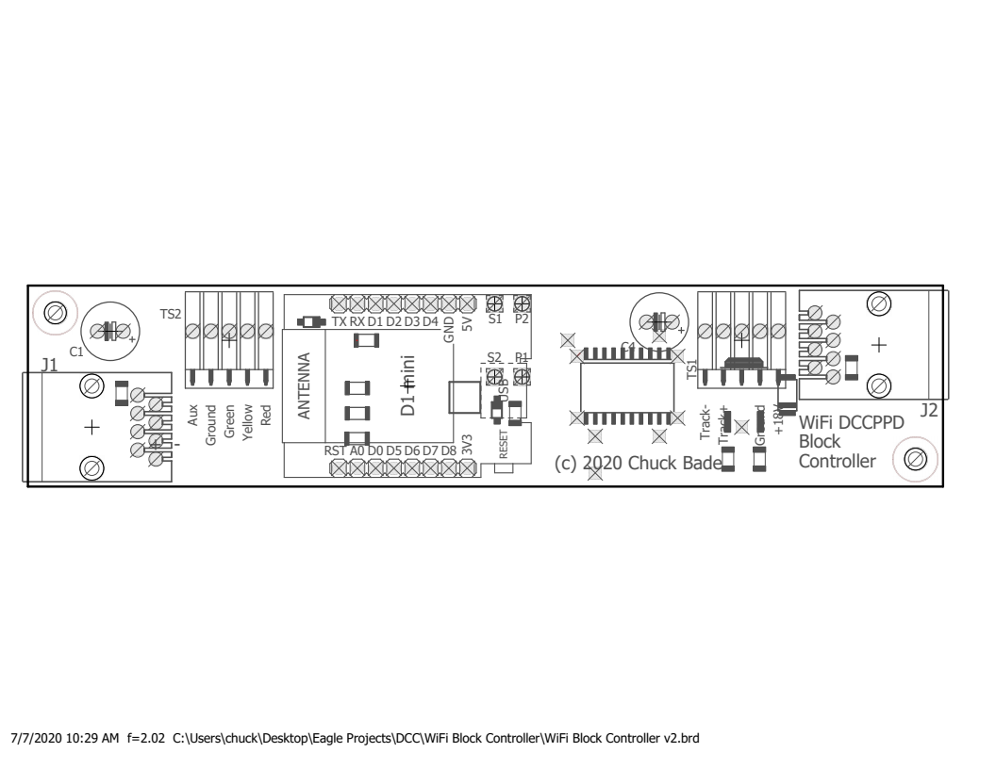Figure 5: Through-Hole Parts Placement
The pads marked P1, P2, S1, and S2 are for the connections to the occupancy detector. This is a transformer wound on 2 ferrite cores with a one turn primary connected from P1 to P2, and a 15 turn secondary, connected from S1 to S2. The primary is a short piece of hookup wire running through the ferrite core. The secondary is 15 turns of wire wrap wire. If it is found to be too sensitive, turns can be removed, but R1 may be able to be adjusted to bring the sensitivity down enough to be reliable.

Testing
Initial testing should be done with the Mini removed.
- Connect a 18VDC power supply to the +18V and Ground connections on the block controller and a piece of test track to Track+ and Track-.
- Connect a CAT5 cable from the base station to the block controller. It doesn’t matter which connector, they’re both the same.
- Measure DC voltage across C2 or C3. You should see 5 volts.
- Assuming you’re using WiThrottle, go into Settings and make sure Track Power is on.
- Measure AC voltage across the track. You should read around 15VAC. If this is OK, skip the next step
- On the back side of the board, find IC1, C5, and C6. IC1 is the 15V regulator. The tab side is ground, the lead next to C5 is the input and the lead next to D6 is the output. With your meter on DC, measure between ground (tab) and output. If you don't see 15v there, check the input side. If you don’t have power coming in to the board, check your wiring.
- Turn off the power.
- Program a mini and plug it in to the block controller. See the Programming section below.
- Turn on the power.
- With nothing on the track, measure DC voltage between pin Mini pin D1 (the junction of C7, D2, and R1) and ground. Adjust R1 for around 2.7 volts. Place a locomotive on the track. The voltage at D1 should go to a close to zero and the blue LED will turn on.
Once the block controller is connected to a regular length of track, the setting of R1 might need to be adjusted if the blue LED stays on all the time. This is due to the capacitance between the feeder wires and between the two rails of the track. This capacitance acts as an AC load on the block controller and could cause the occupancy detector to be falsely triggered. I suspect that this will be worse on N-scale than on HO or other larger gauged rails. If you find it difficult to achieve proper operation, try reducing the length of feeder wire. The block controllers were meant to be distributed around the layout. If instead, they are all grouped together and longer feeder wires run around the layout, the occupancy detectors will probably not work.

Programming

Numbering Inputs and Outputs
The numbers for inputs from MQTT are independent of the output numbers. They could have the same numbers as inputs or completely separate. I prefer to have my turnouts at low numbers, leave enough room for expansion, then have my signal light outputs at some higher range. The reason for this is that internally JMRI treats all outputs as turnouts, and when you want to throw a turnout with WiThrottle, having the turnouts first in the list will help you avoid doing a lot of scrolling to get to your turnouts.
A note about turntables and staging yard transfer tables. Each ray in a turntable is treated as a turnout in JMRI, and "throwing" the turnout sends a command to move the table to that ray. You need to reserve enough turnout numbers for however many rays you have. Again, these need to be lower numbers so you can select the rays with WiThrottle.
Since lights are generally set automatically, the numbers for them can be set to high values, out of the way of outputs that need more frequent access.
Each light in a signal head is one output, so remember to leave space. I have an extra output on my block controller, called "aux", so I leave an extra number for that. Since the D1 Mini that is on the block controller has up to 6 outputs, it wouldn't hurt to leave space for 6 total. For example, my first light (green) on my first block controller is at 800, and the green light on the second block controller is at 806.
So my output numbering scheme is a follows:
- 60-99 Turnouts
- 100-199 Turntables/Transfer Tables
- 800-805 1st Block (green, yellow, red, aux, future1 future2)
- 806-811 2nd Block
…
- 944-949 25th Block
Inputs can have the same numbers as outputs, but to avoid confusion, I've chosen a different series of numbers.
- 400-499 Turnout Feedback Sensors (not currently working)
- 500-599 Block Occupancy Detectors
- 500 1st Block Detector
- 501 (future use, unused input on block controller)
- 502 2nd Block Detector
- 503 (future use)

Setting up Arduino IDE
- Install Arduino IDE.
- In Arduino IDE, go to File->Preferences and enter http://arduino.esp8266.com/stable/package_esp8266com_index.json into the “Additional Boards Manager URLs” field.
- Go to Tools->Board->Boards Manager…, search for ESP8266 and press the install button for the “ESP8266 by ESP8266 Community“.
You will probably need the following libraries:
- Servo by Michael Margolis
- Stepper by Arduino
- WiFi by Arduino
- PubSubClient by Nick O'Leary
- Ethernet by various

D1 Mini Configuration
- Go to https://github.com/chuckbade/MQTT
- Download the latest ino file from the MQTT Block Controller directory.
- Open it in Arduino IDE.
- Change the values near the top of the sketch to match your network.
- Change the JMRISensorNumber, JMRIGreenNumber, JMRIYellowNumber, JMRIRedNumber, and JMRIAuxNumber for the block being configured.
- Connect the Mini to the USB cable and compile the sketch.
- After is says it is resetting the device, disconnect the Mini and connect it to the block controller.

JMRI Configuration
NOTE: You must have JMRI version 4.21.1 or newer for MQTT to work with sensors.
- From the main PanelPro menu, go to Tools→Tables→Sensors.
- Click Add…. The Add New Sensor dialog will appear.
- If System Connection is not showing MQTT, select it in the pull-down. If MQTT is not listed in the pull-down, then the installed version of JMRI is too old. See the note above.
- Enter your desired sensor number in the Hardware Address field.
- Enter a name for the turnout sensor in the User Name field.
- Click Create. The new sensor should now be listed in the sensor table.
- Repeat steps 2 through 6 for each occupancy detector you need to add.
- In the list on the left side of the window, select Signal Heads.
- Click Add…. The Add New Signal Head dialog will appear.
- In the pull-down below the menu, select Triple Output.
- Enter a name, starting with “MH” in the System Name field.
- Enter a name (description) in the User Name field.
- In each of the color output boxes you will enter an output. Select MQTT if it is not already selected.
- You have a choice of using existing outputs from the turnout table, or creating new ones. It’s easier to create new ones in this dialog. In each box, click Create New and enter a system ID, beginning with “MT”.
- Click Create.
- Repeat steps 9 through 14 for each signal head you need to add.
- Don't forget to save your changes. (File->Store->Store Configuration and Panels to File…)
Signal Masts will also need to be created but that will not be covered here. You can find information about that on the internet.

Variations
Of course any of the functions are optional on a fully built board, but if you want to save a little money and time installing certain parts, then you may choose to leave some parts off.
If a track driver is needed without a signal light, then don’t install R3, R4, R5, and TS2.
If a track driver is needed without a signal light and without an occupancy sensor, then don’t install R1, R2, R3, R4, R5, D2, C8, TS2, and the Mini. Also install a wire from P1 to P2 without a ferrite core.
If only a signal light is needed without a track driver, then don’t install IC3, IC5, R1, D1, D2, C4, C5, C6, C8, and TS1. Also, if you only need a signal light, then the RJ45 (CAT5) connectors are not needed. Instead the 5V and ground wires can be solder directly to the board, with 5V on pin 1 and ground on pin 2 of either RJ45. These pins are located next to either C2 or C3.
Table 3: Component Options
Option/Component | C1 | C2 | C3 | C4 | C5 | C6 | C8 | D1 | D2 | IC3 | IC5 | R1 | R2 | R3 | R4 | R5 | TS1 | TS2 | OD | Mini
Full Featured | X | X | X | X | X | X | X | X | X | X | X | X | X | X | X | X | X | X | X | X
Track Driver & OD | X | X | X | X | X | X | X | X | X | X | X | X | X |  |  |  | X |  | X | X
Track Driver | X | X | X | X | X | X |  | X | X | X | X |  |  |  |  |  | X
Signal Lights | X | X | X |  |  |  |  |  |  |  |  |  | X | X | X | X | X | X |  | X

